Mycro Farms Team Meeting NoteBook

By Timothy Caole, Anthony Le, Angelica Quinto, Enrique Arley-Imhoff, James Oelund

# 

# Table of Contents

**Table of Contents 1**

**Week 2 Report: 2**

**Week 3 Report: 4**

**Week 4 Report: 5**

**Week #5 Report: 6**

**Week #7 Report: 7**

**Week #8-10 Report: 8**

**Week #11 Report: 9**

10/5/2023

# **Week 2 Report:**

10:45 am - 11:30 am

**Idea presentation:** everyone

***Task:***

Angelics: O2 sensor

Tim: Motor + ultrasonic sensor

James: Relay +

Enrique CO2 sensor

Anthony : humidity + temp sensor

***Team Meeting Notes:***

Find another source of heat instead of LED.

Do calculations for a schematic of the project and amount of CO2 is produced and how much O2 it takes.

Look into a bi-directional fan or 2. // leading towards 2 fans

Try to make the box airtight

* We might have to rubber-line the

***Question/Recommendations from the presentation:***

Do Results of yield (lbs of mushroom) with the following condition

-Growing mushrooms w/out containers, with containers in ideal conditions,

- conditioner with horrible conditions,

- Compare the yield produced from those conditions 2)

Do the calculation for mushroom ventilation, how much CO2 is produced, and how much O2 it takes.

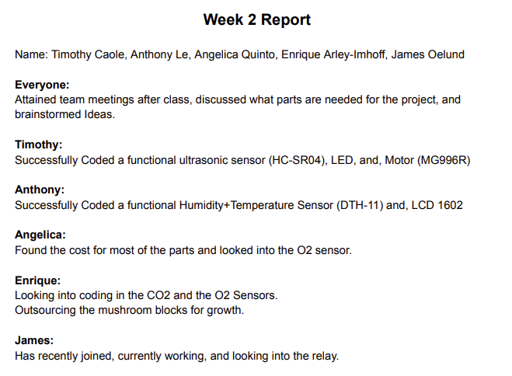

# **Week 3 Report:**

# **Week 4 Report:**

# **Week #5 Report:**

# **Week #7 Report:**

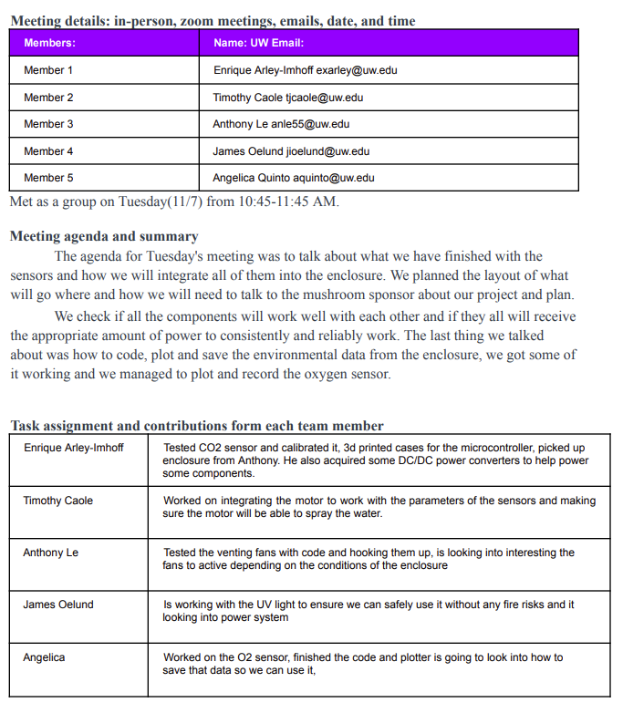

# **Week #8-10 Report:**

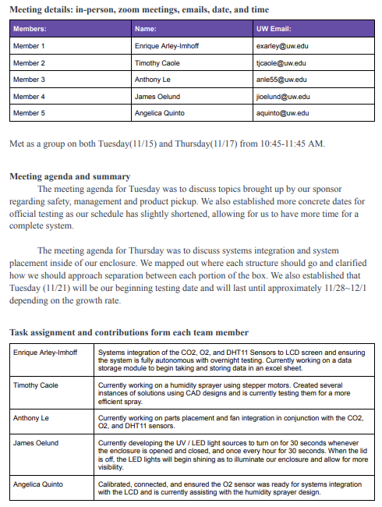

# **Week #11 Report:**